Automatic Mechanical Garage Door Opener

Here we propose a fully automatic garage door opener project system. To achieve the design and fabrication of an automated garage door opener system we use a large screw with fabricated door belt, pulley, connecting rods, fixtures, mounts, motor and supporting frame. Proposed system will use a fabricate mini door mounted on the threaded screw to efficiently transfer motor power for achieving radial motion of the door. We use a pulley and belt arrangement in order to drive the screw by transferring motor power to the screw. The screw rotation moves the door in desired direction using threading. We use a switch to run the motor in desired direction for both way motion.

Components
- 12V motor
- Mini Door
- Screws
- Pulley
- Belt
- Mounts
- Supporting Frame
- Joints & Fixtures

Advantages
- Automated Door Opening & Closing
- Smooth Regulated Door Motion

Block Diagram:

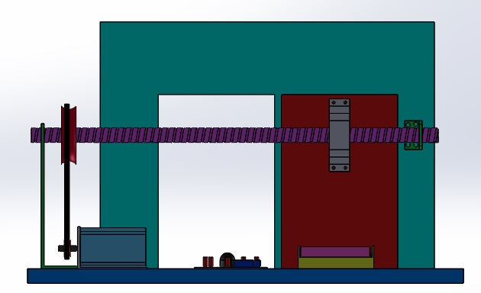
Block Diagram

